Screenshots Agenda

All steps are described in project readme file.

All source codes are included in project.

Project Github: <https://github.com/serjikisagholian/capstone-k8s>

1. AWS EC2 dashboard before beginning
2. Provisioning AWS using Ansible
3. Provisioning Kubernetes cluster on AWS
4. Provisioning Vagrant instances, Kubernetes, FlaskApp deployment and custom service account
5. Take snapshot from ETCD
6. Check Custom Service Account permissions
7. Testing HorizontalPodAutoscaler and number of pods with CPU usage increase

Start with a clean dashboard

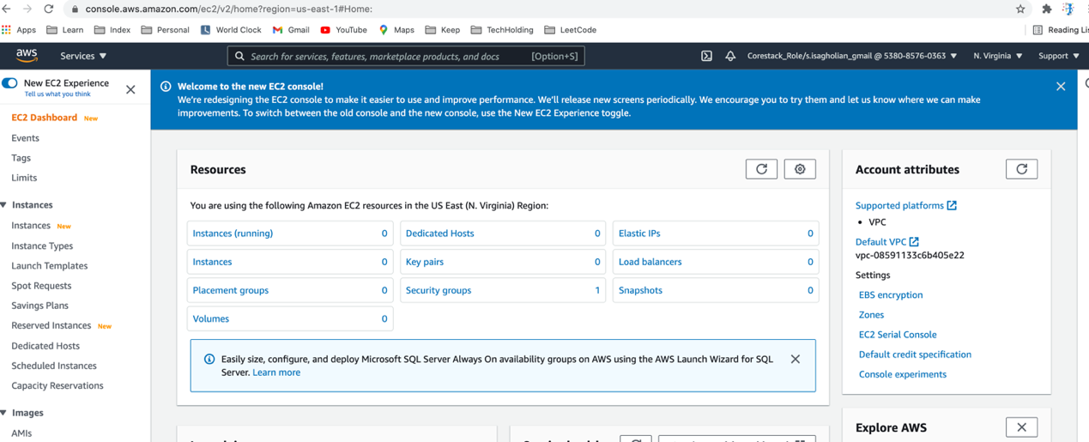

Provision AWS with ansible

>> export AWS_ACCESS_KEY_ID=<AWS_ACCESS_KEY>

>> export AWS_SECRET_ACCESS_KEY=<AWS_SECRET_KEY>

>> export AWS_SECURITY_TOKEN=<AWS_SECURITY_TOKEN>

>> export AWS_REGION=<AWS_REGION>

>> cd aws-version

>> ansible-playbook provision.yml

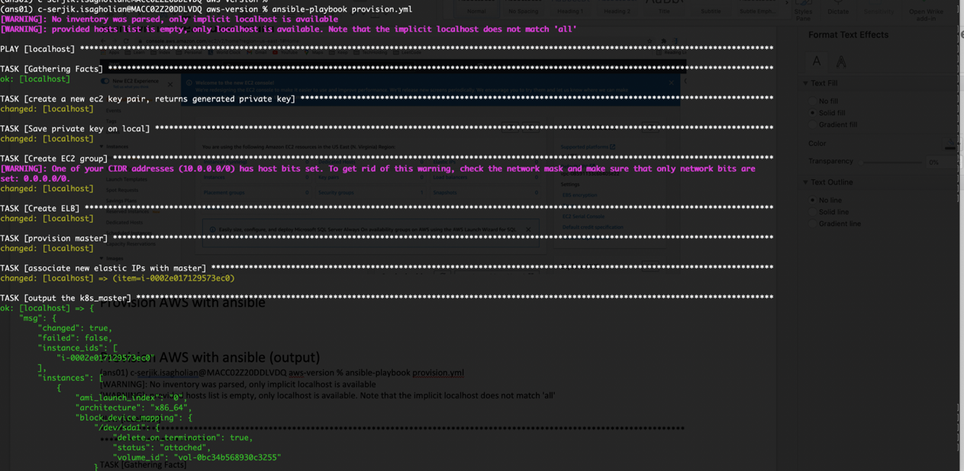Provision

AWS with ansible (output)

(ans01) c-serjik.isagholian@MACC02Z20DDLVDQ aws-version % ansible-playbook provision.yml

[WARNING]: No inventory was parsed, only implicit localhost is available

[WARNING]: provided hosts list is empty, only localhost is available. Note that the implicit localhost does not match 'all'

PLAY [localhost] ****************************************************************************************************************************************************

TASK [Gathering Facts] **********************************************************************************************************************************************

ok: [localhost]

TASK [create a new ec2 key pair, returns generated private key] *****************************************************************************************************

changed: [localhost]

TASK [Save private key on local] ************************************************************************************************************************************

changed: [localhost]

TASK [Create EC2 group] *********************************************************************************************************************************************

[WARNING]: One of your CIDR addresses (10.0.0.0/0) has host bits set. To get rid of this warning, check the network mask and make sure that only network bits are

set: 0.0.0.0/0.

changed: [localhost]

TASK [Create ELB] ***************************************************************************************************************************************************

changed: [localhost]

TASK [provision master] *********************************************************************************************************************************************

changed: [localhost]

TASK [associate new elastic IPs with master] ************************************************************************************************************************

changed: [localhost] => (item=i-0002e017129573ec0)

TASK [output the k8s_master] ****************************************************************************************************************************************

ok: [localhost] => {

"msg": {

"changed": true,

"failed": false,

"instance_ids": [

"i-0002e017129573ec0"

],

"instances": [

{

"ami_launch_index": "0",

"architecture": "x86_64",

"block_device_mapping": {

"/dev/sda1": {

"delete_on_termination": true,

"status": "attached",

"volume_id": "vol-0bc34b568930c3255"

}

},

"dns_name": "ec2-54-210-134-184.compute-1.amazonaws.com",

"ebs_optimized": false,

"groups": {

"sg-0ac101e3ee1f7ba33": "ec2group01",

"sg-0e22a51bed7c7da61": "default_elb_9832fbe7-68b3-3f05-b5bf-59b60f9c9f76"

},

"hypervisor": "xen",

"id": "i-0002e017129573ec0",

"image_id": "ami-0747bdcabd34c712a",

"instance_type": "t2.micro",

"kernel": null,

"key_name": "my_keypair",

"launch_time": "2021-05-14T19:09:15.000Z",

"placement": "us-east-1d",

"private_dns_name": "ip-172-31-23-208.ec2.internal",

"private_ip": "172.31.23.208",

"public_dns_name": "ec2-54-210-134-184.compute-1.amazonaws.com",

"public_ip": "54.210.134.184",

"ramdisk": null,

"region": "us-east-1",

"root_device_name": "/dev/sda1",

"root_device_type": "ebs",

"state": "running",

"state_code": 16,

"tags": {},

"tenancy": "default",

"virtualization_type": "hvm"

}

],

"tagged_instances": []

}

}

TASK [output master_ips] ********************************************************************************************************************************************

ok: [localhost] => {

"msg": {

"changed": true,

"msg": "All items completed",

"results": [

{

"allocation_id": "eipalloc-04f7c0f5006f784c3",

"ansible_loop_var": "item",

"changed": true,

"failed": false,

"invocation": {

"module_args": {

"allow_reassociation": false,

"aws_access_key": null,

"aws_ca_bundle": null,

"aws_config": null,

"aws_secret_key": null,

"debug_botocore_endpoint_logs": false,

"device_id": "i-0002e017129573ec0",

"ec2_url": null,

"in_vpc": true,

"private_ip_address": null,

"profile": null,

"public_ip": null,

"public_ipv4_pool": null,

"region": null,

"release_on_disassociation": false,

"reuse_existing_ip_allowed": false,

"security_token": null,

"state": "present",

"tag_name": null,

"tag_value": null,

"validate_certs": true,

"wait_timeout": null

}

},

"item": "i-0002e017129573ec0",

"public_ip": "3.210.215.168"

}

]

}

}

TASK [Create a fresh inventory] *************************************************************************************************************************************

changed: [localhost]

TASK [Add master to local host group] *******************************************************************************************************************************

changed: [localhost] => (item={'changed': True, 'public_ip': '3.210.215.168', 'allocation_id': 'eipalloc-04f7c0f5006f784c3', 'invocation': {'module_args': {'device_id': 'i-0002e017129573ec0', 'in_vpc': True, 'debug_botocore_endpoint_logs': False, 'validate_certs': True, 'state': 'present', 'reuse_existing_ip_allowed': False, 'release_on_disassociation': False, 'allow_reassociation': False, 'ec2_url': None, 'aws_access_key': None, 'aws_secret_key': None, 'security_token': None, 'aws_ca_bundle': None, 'profile': None, 'aws_config': None, 'region': None, 'public_ip': None, 'wait_timeout': None, 'private_ip_address': None, 'tag_name': None, 'tag_value': None, 'public_ipv4_pool': None}}, 'failed': False, 'item': 'i-0002e017129573ec0', 'ansible_loop_var': 'item'})

TASK [Wait for servers to come online] ******************************************************************************************************************************

ok: [localhost] => (item={'changed': True, 'public_ip': '3.210.215.168', 'allocation_id': 'eipalloc-04f7c0f5006f784c3', 'invocation': {'module_args': {'device_id': 'i-0002e017129573ec0', 'in_vpc': True, 'debug_botocore_endpoint_logs': False, 'validate_certs': True, 'state': 'present', 'reuse_existing_ip_allowed': False, 'release_on_disassociation': False, 'allow_reassociation': False, 'ec2_url': None, 'aws_access_key': None, 'aws_secret_key': None, 'security_token': None, 'aws_ca_bundle': None, 'profile': None, 'aws_config': None, 'region': None, 'public_ip': None, 'wait_timeout': None, 'private_ip_address': None, 'tag_name': None, 'tag_value': None, 'public_ipv4_pool': None}}, 'failed': False, 'item': 'i-0002e017129573ec0', 'ansible_loop_var': 'item'})

TASK [Add master as known hosts] ************************************************************************************************************************************

changed: [localhost] => (item={'changed': True, 'public_ip': '3.210.215.168', 'allocation_id': 'eipalloc-04f7c0f5006f784c3', 'invocation': {'module_args': {'device_id': 'i-0002e017129573ec0', 'in_vpc': True, 'debug_botocore_endpoint_logs': False, 'validate_certs': True, 'state': 'present', 'reuse_existing_ip_allowed': False, 'release_on_disassociation': False, 'allow_reassociation': False, 'ec2_url': None, 'aws_access_key': None, 'aws_secret_key': None, 'security_token': None, 'aws_ca_bundle': None, 'profile': None, 'aws_config': None, 'region': None, 'public_ip': None, 'wait_timeout': None, 'private_ip_address': None, 'tag_name': None, 'tag_value': None, 'public_ipv4_pool': None}}, 'failed': False, 'item': 'i-0002e017129573ec0', 'ansible_loop_var': 'item'})

TASK [provision nodes] **********************************************************************************************************************************************

changed: [localhost]

TASK [associate new elastic IPs with nodes] *************************************************************************************************************************

changed: [localhost] => (item=i-05761120bc07e5dfa)

changed: [localhost] => (item=i-0bb183fa6d4e0b4d3)

TASK [Add nodes section to inventory] *******************************************************************************************************************************

changed: [localhost]

TASK [Add nodes to local host group] ********************************************************************************************************************************

changed: [localhost] => (item={'changed': True, 'public_ip': '52.21.155.93', 'allocation_id': 'eipalloc-0067f0820a5f5d2d7', 'invocation': {'module_args': {'device_id': 'i-05761120bc07e5dfa', 'in_vpc': True, 'debug_botocore_endpoint_logs': False, 'validate_certs': True, 'state': 'present', 'reuse_existing_ip_allowed': False, 'release_on_disassociation': False, 'allow_reassociation': False, 'ec2_url': None, 'aws_access_key': None, 'aws_secret_key': None, 'security_token': None, 'aws_ca_bundle': None, 'profile': None, 'aws_config': None, 'region': None, 'public_ip': None, 'wait_timeout': None, 'private_ip_address': None, 'tag_name': None, 'tag_value': None, 'public_ipv4_pool': None}}, 'failed': False, 'item': 'i-05761120bc07e5dfa', 'ansible_loop_var': 'item'})

changed: [localhost] => (item={'changed': True, 'public_ip': '3.232.24.170', 'allocation_id': 'eipalloc-0c29084297192d25f', 'invocation': {'module_args': {'device_id': 'i-0bb183fa6d4e0b4d3', 'in_vpc': True, 'debug_botocore_endpoint_logs': False, 'validate_certs': True, 'state': 'present', 'reuse_existing_ip_allowed': False, 'release_on_disassociation': False, 'allow_reassociation': False, 'ec2_url': None, 'aws_access_key': None, 'aws_secret_key': None, 'security_token': None, 'aws_ca_bundle': None, 'profile': None, 'aws_config': None, 'region': None, 'public_ip': None, 'wait_timeout': None, 'private_ip_address': None, 'tag_name': None, 'tag_value': None, 'public_ipv4_pool': None}}, 'failed': False, 'item': 'i-0bb183fa6d4e0b4d3', 'ansible_loop_var': 'item'})

TASK [Wait for servers to come online] ******************************************************************************************************************************

ok: [localhost] => (item={'changed': True, 'public_ip': '52.21.155.93', 'allocation_id': 'eipalloc-0067f0820a5f5d2d7', 'invocation': {'module_args': {'device_id': 'i-05761120bc07e5dfa', 'in_vpc': True, 'debug_botocore_endpoint_logs': False, 'validate_certs': True, 'state': 'present', 'reuse_existing_ip_allowed': False, 'release_on_disassociation': False, 'allow_reassociation': False, 'ec2_url': None, 'aws_access_key': None, 'aws_secret_key': None, 'security_token': None, 'aws_ca_bundle': None, 'profile': None, 'aws_config': None, 'region': None, 'public_ip': None, 'wait_timeout': None, 'private_ip_address': None, 'tag_name': None, 'tag_value': None, 'public_ipv4_pool': None}}, 'failed': False, 'item': 'i-05761120bc07e5dfa', 'ansible_loop_var': 'item'})

ok: [localhost] => (item={'changed': True, 'public_ip': '3.232.24.170', 'allocation_id': 'eipalloc-0c29084297192d25f', 'invocation': {'module_args': {'device_id': 'i-0bb183fa6d4e0b4d3', 'in_vpc': True, 'debug_botocore_endpoint_logs': False, 'validate_certs': True, 'state': 'present', 'reuse_existing_ip_allowed': False, 'release_on_disassociation': False, 'allow_reassociation': False, 'ec2_url': None, 'aws_access_key': None, 'aws_secret_key': None, 'security_token': None, 'aws_ca_bundle': None, 'profile': None, 'aws_config': None, 'region': None, 'public_ip': None, 'wait_timeout': None, 'private_ip_address': None, 'tag_name': None, 'tag_value': None, 'public_ipv4_pool': None}}, 'failed': False, 'item': 'i-0bb183fa6d4e0b4d3', 'ansible_loop_var': 'item'})

TASK [Add nodes as known hosts] *************************************************************************************************************************************

changed: [localhost] => (item={'changed': True, 'public_ip': '52.21.155.93', 'allocation_id': 'eipalloc-0067f0820a5f5d2d7', 'invocation': {'module_args': {'device_id': 'i-05761120bc07e5dfa', 'in_vpc': True, 'debug_botocore_endpoint_logs': False, 'validate_certs': True, 'state': 'present', 'reuse_existing_ip_allowed': False, 'release_on_disassociation': False, 'allow_reassociation': False, 'ec2_url': None, 'aws_access_key': None, 'aws_secret_key': None, 'security_token': None, 'aws_ca_bundle': None, 'profile': None, 'aws_config': None, 'region': None, 'public_ip': None, 'wait_timeout': None, 'private_ip_address': None, 'tag_name': None, 'tag_value': None, 'public_ipv4_pool': None}}, 'failed': False, 'item': 'i-05761120bc07e5dfa', 'ansible_loop_var': 'item'})

changed: [localhost] => (item={'changed': True, 'public_ip': '3.232.24.170', 'allocation_id': 'eipalloc-0c29084297192d25f', 'invocation': {'module_args': {'device_id': 'i-0bb183fa6d4e0b4d3', 'in_vpc': True, 'debug_botocore_endpoint_logs': False, 'validate_certs': True, 'state': 'present', 'reuse_existing_ip_allowed': False, 'release_on_disassociation': False, 'allow_reassociation': False, 'ec2_url': None, 'aws_access_key': None, 'aws_secret_key': None, 'security_token': None, 'aws_ca_bundle': None, 'profile': None, 'aws_config': None, 'region': None, 'public_ip': None, 'wait_timeout': None, 'private_ip_address': None, 'tag_name': None, 'tag_value': None, 'public_ipv4_pool': None}}, 'failed': False, 'item': 'i-0bb183fa6d4e0b4d3', 'ansible_loop_var': 'item'})

PLAY RECAP **********************************************************************************************************************************************************

localhost : ok=19 changed=14 unreachable=0 failed=0 skipped=0 rescued=0 ignored=0

(ans01) c-serjik.isagholian@MACC02Z20DDLVDQ aws-version %

Dashboard after provisioning

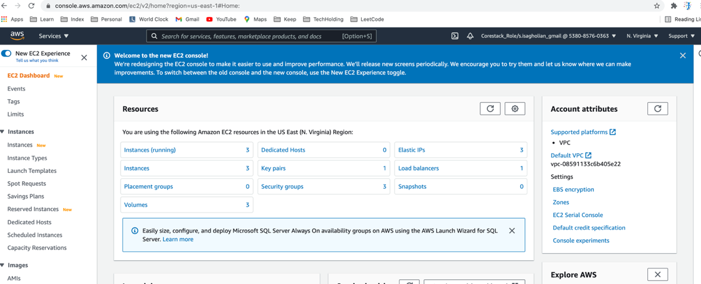

Instances

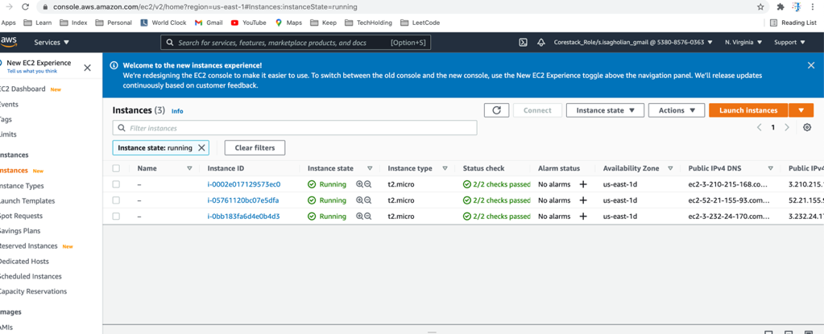

Master node

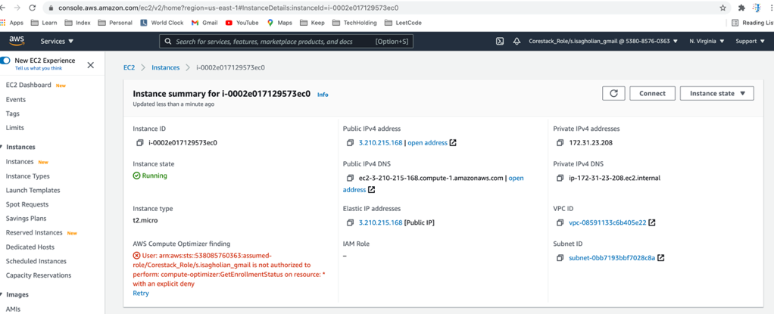

EC2 Group Assigned

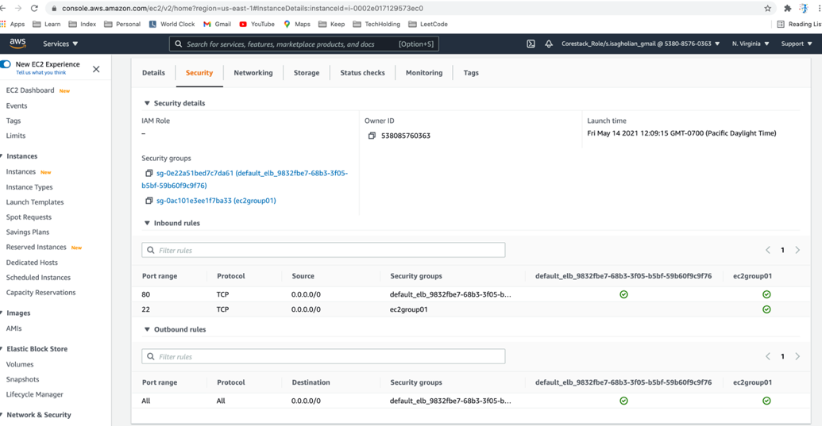

Ansible hosts file after provisioning

[k8s_master]

3.210.215.168 ansible_user=ubuntu ansible_ssh_private_key_file=~/.aws/my_keypair.pem

[k8s_nodes]

52.21.155.93 ansible_user=ubuntu ansible_ssh_private_key_file=~/.aws/my_keypair.pem

3.232.24.170 ansible_user=ubuntu ansible_ssh_private_key_file=~/.aws/my_keypair.pem

Testing connectivity

>> ansible -m ping k8s_master -i ansible_hosts

>> ansible -m ping k8s_nodes -i ansible_hosts

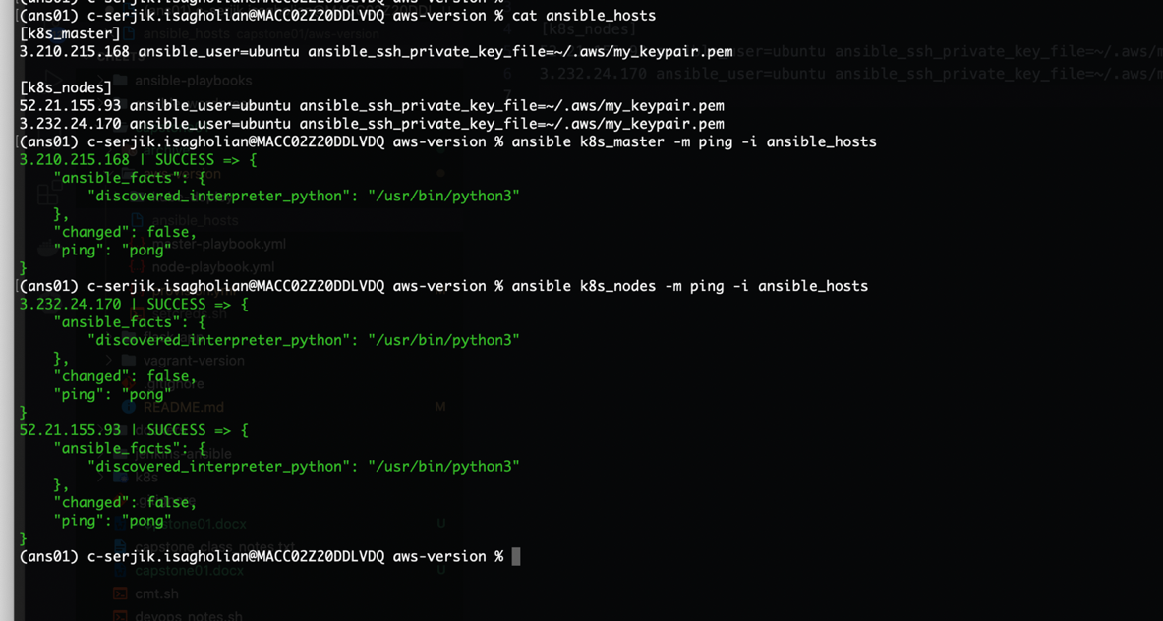

Provisioning Kubernetes (need at least t3.small for master – 2 cores, 1700 Mib)

>> ansible-playbook master-playbook.yml -i ansible_hosts

>> ansible-playbook node-playbook.yml -i ansible_hosts

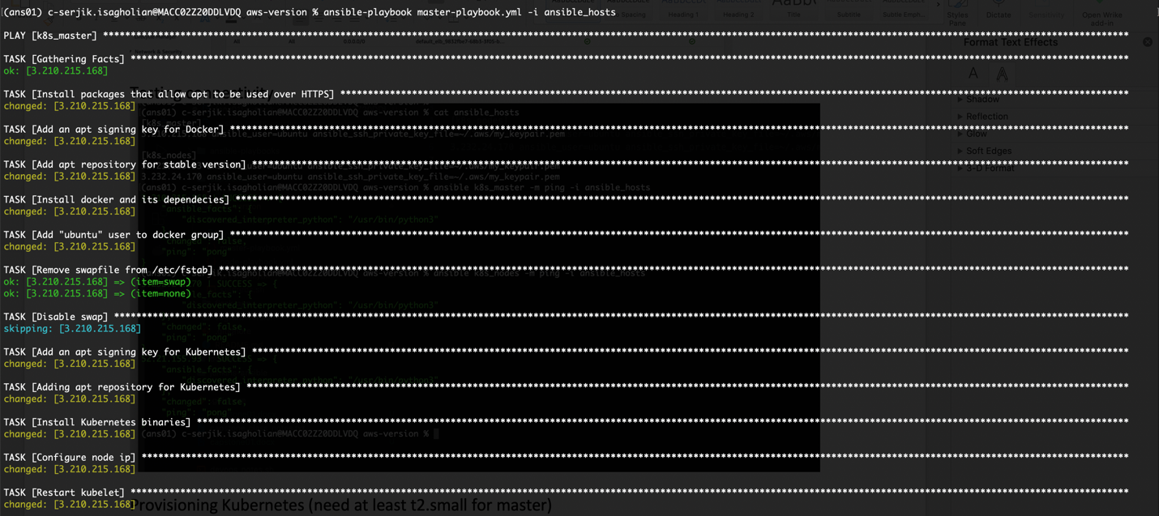

The following error shows lack of enough resources (we need at least t3.small for master)

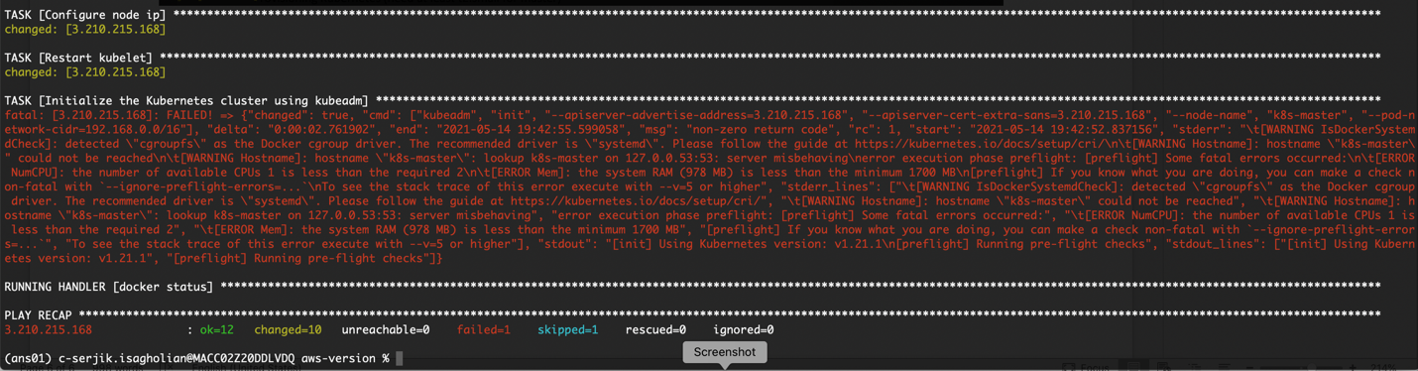

Ansible output

(ans01) c-serjik.isagholian@MACC02Z20DDLVDQ aws-version % ansible-playbook master-playbook.yml -i ansible_hosts

PLAY [k8s_master] ******************************************************************************************************************************************************************************************

TASK [Gathering Facts] *************************************************************************************************************************************************************************************

ok: [3.210.215.168]

TASK [Install packages that allow apt to be used over HTTPS] ***********************************************************************************************************************************************

changed: [3.210.215.168]

TASK [Add an apt signing key for Docker] *******************************************************************************************************************************************************************

changed: [3.210.215.168]

TASK [Add apt repository for stable version] ***************************************************************************************************************************************************************

changed: [3.210.215.168]

TASK [Install docker and its dependecies] ******************************************************************************************************************************************************************

changed: [3.210.215.168]

TASK [Add "ubuntu" user to docker group] *******************************************************************************************************************************************************************

changed: [3.210.215.168]

TASK [Remove swapfile from /etc/fstab] *********************************************************************************************************************************************************************

ok: [3.210.215.168] => (item=swap)

ok: [3.210.215.168] => (item=none)

TASK [Disable swap] ****************************************************************************************************************************************************************************************

skipping: [3.210.215.168]

TASK [Add an apt signing key for Kubernetes] ***************************************************************************************************************************************************************

changed: [3.210.215.168]

TASK [Adding apt repository for Kubernetes] ****************************************************************************************************************************************************************

changed: [3.210.215.168]

TASK [Install Kubernetes binaries] *************************************************************************************************************************************************************************

changed: [3.210.215.168]

TASK [Configure node ip] ***********************************************************************************************************************************************************************************

changed: [3.210.215.168]

TASK [Restart kubelet] *************************************************************************************************************************************************************************************

changed: [3.210.215.168]

TASK [Initialize the Kubernetes cluster using kubeadm] *****************************************************************************************************************************************************

fatal: [3.210.215.168]: FAILED! => {"changed": true, "cmd": ["kubeadm", "init", "--apiserver-advertise-address=3.210.215.168", "--apiserver-cert-extra-sans=3.210.215.168", "--node-name", "k8s-master", "--pod-network-cidr=192.168.0.0/16"], "delta": "0:00:02.761902", "end": "2021-05-14 19:42:55.599058", "msg": "non-zero return code", "rc": 1, "start": "2021-05-14 19:42:52.837156", "stderr": "\t[WARNING IsDockerSystemdCheck]: detected \"cgroupfs\" as the Docker cgroup driver. The recommended driver is \"systemd\". Please follow the guide at https://kubernetes.io/docs/setup/cri/\n\t[WARNING Hostname]: hostname \"k8s-master\" could not be reached\n\t[WARNING Hostname]: hostname \"k8s-master\": lookup k8s-master on 127.0.0.53:53: server misbehaving\nerror execution phase preflight: [preflight] Some fatal errors occurred:\n\t[ERROR NumCPU]: the number of available CPUs 1 is less than the required 2\n\t[ERROR Mem]: the system RAM (978 MB) is less than the minimum 1700 MB\n[preflight] If you know what you are doing, you can make a check non-fatal with `--ignore-preflight-errors=...`\nTo see the stack trace of this error execute with --v=5 or higher", "stderr_lines": ["\t[WARNING IsDockerSystemdCheck]: detected \"cgroupfs\" as the Docker cgroup driver. The recommended driver is \"systemd\". Please follow the guide at https://kubernetes.io/docs/setup/cri/", "\t[WARNING Hostname]: hostname \"k8s-master\" could not be reached", "\t[WARNING Hostname]: hostname \"k8s-master\": lookup k8s-master on 127.0.0.53:53: server misbehaving", "error execution phase preflight: [preflight] Some fatal errors occurred:", "\t[ERROR NumCPU]: the number of available CPUs 1 is less than the required 2", "\t[ERROR Mem]: the system RAM (978 MB) is less than the minimum 1700 MB", "[preflight] If you know what you are doing, you can make a check non-fatal with `--ignore-preflight-errors=...`", "To see the stack trace of this error execute with --v=5 or higher"], "stdout": "[init] Using Kubernetes version: v1.21.1\n[preflight] Running pre-flight checks", "stdout_lines": ["[init] Using Kubernetes version: v1.21.1", "[preflight] Running pre-flight checks"]}

RUNNING HANDLER [docker status] ****************************************************************************************************************************************************************************

PLAY RECAP *************************************************************************************************************************************************************************************************

3.210.215.168 : ok=12 changed=10 unreachable=0 failed=1 skipped=1 rescued=0 ignored=0

(ans01) c-serjik.isagholian@MACC02Z20DDLVDQ aws-version %

For rest of the demo we will switch to Vagrant version, because with AWS free version we could not have resources to fulfill.

**Vagrant file**

IMAGE_NAME = "bento/ubuntu-18.04"

N = 2

Vagrant.configure("2") do |config|

config.ssh.insert_key = false

config.vm.provider "virtualbox" do |v|

v.memory = 6144

v.cpus = 4

end

config.vm.define "k8s-master" do |master|

master.vm.box = IMAGE_NAME

master.vm.network "private_network", ip: "192.168.50.10"

master.vm.hostname = "k8s-master"

master.vm.provision "ansible" do |ansible|

ansible.playbook = "kubernetes-setup/master-playbook.yml"

ansible.extra_vars = {

node_ip: "192.168.50.10",

}

end

end

(1..N).each do |i|

config.vm.define "node-#{i}" do |node|

node.vm.box = IMAGE_NAME

node.vm.network "private_network", ip: "192.168.50.#{i + 10}"

node.vm.hostname = "node-#{i}"

node.vm.provision "ansible" do |ansible|

ansible.playbook = "kubernetes-setup/node-playbook.yml"

ansible.extra_vars = {

node_ip: "192.168.50.#{i + 10}",

}

end

end

end

end

**Provisioning on Vagrant**

>> cd vagrant-version

>> vagrant up

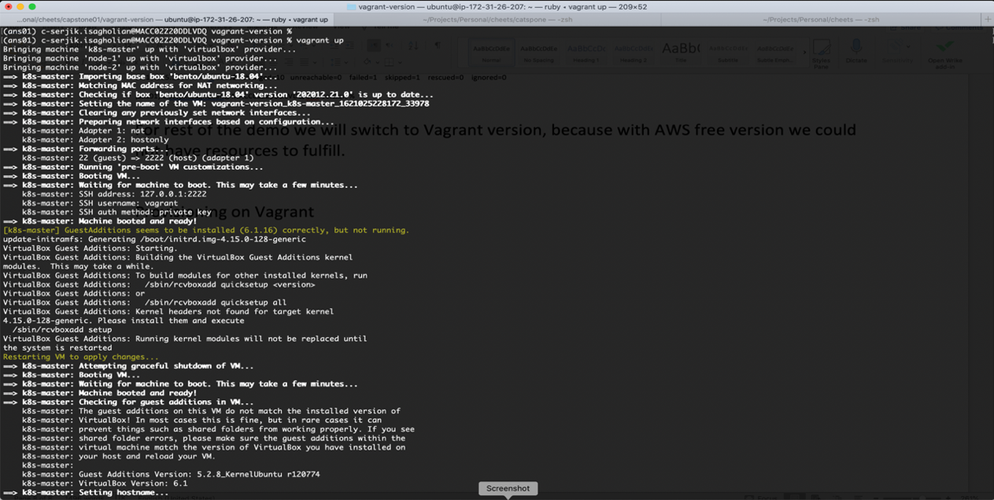

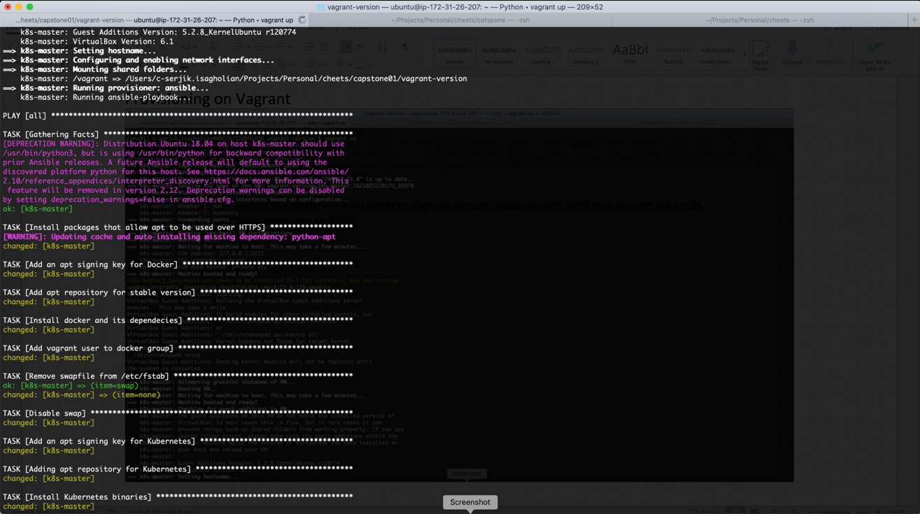

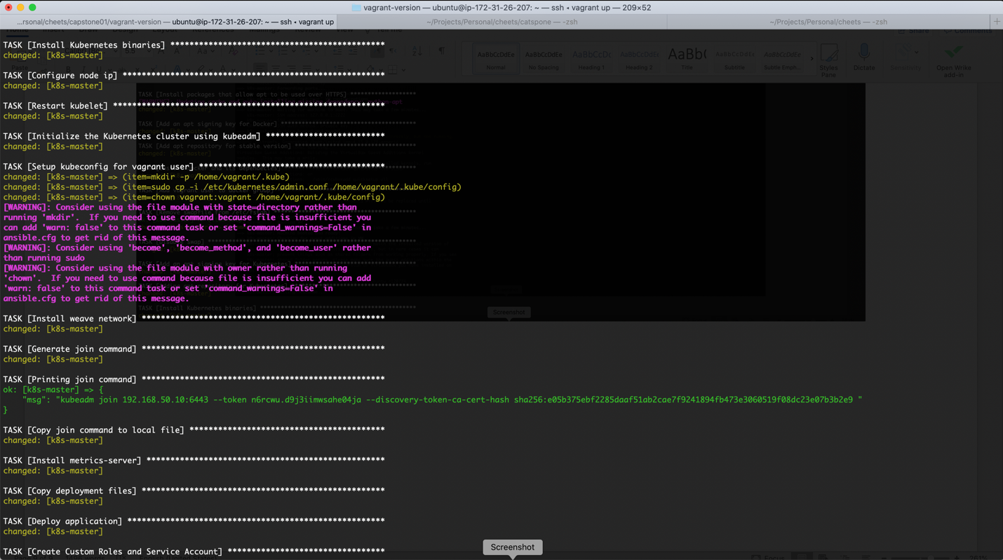

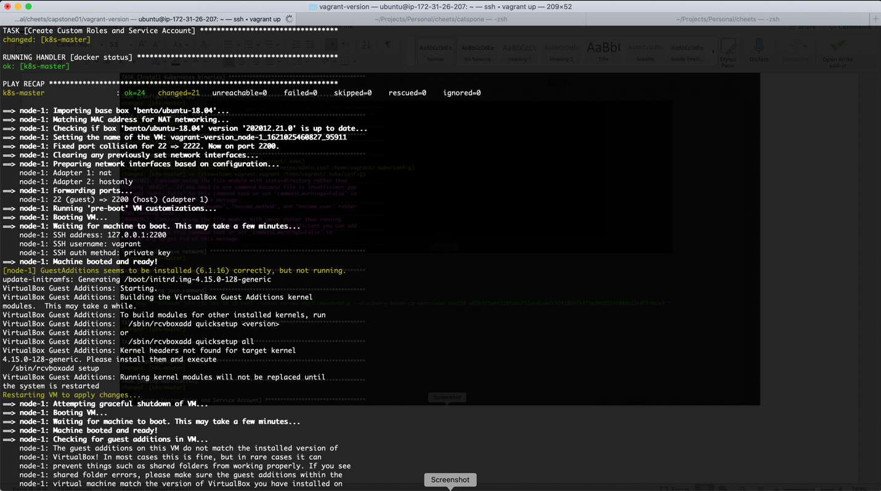

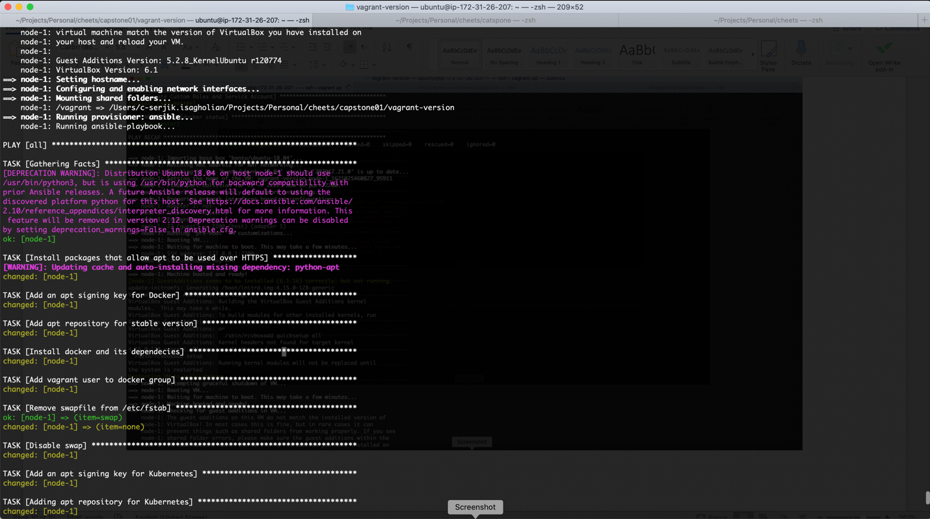

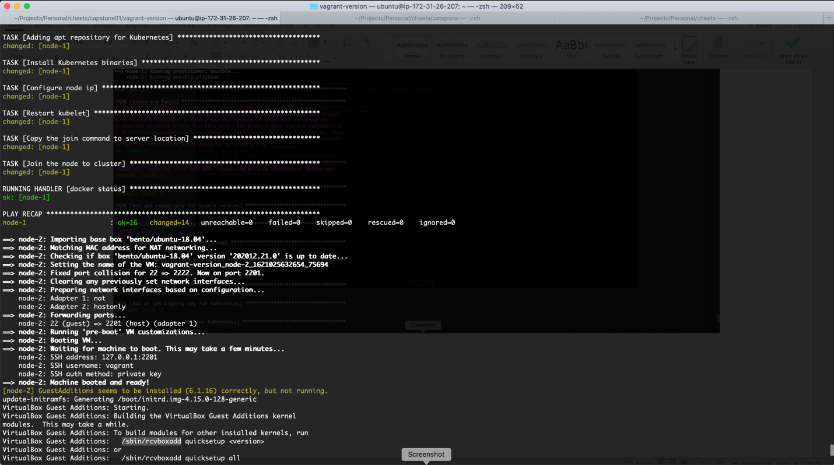

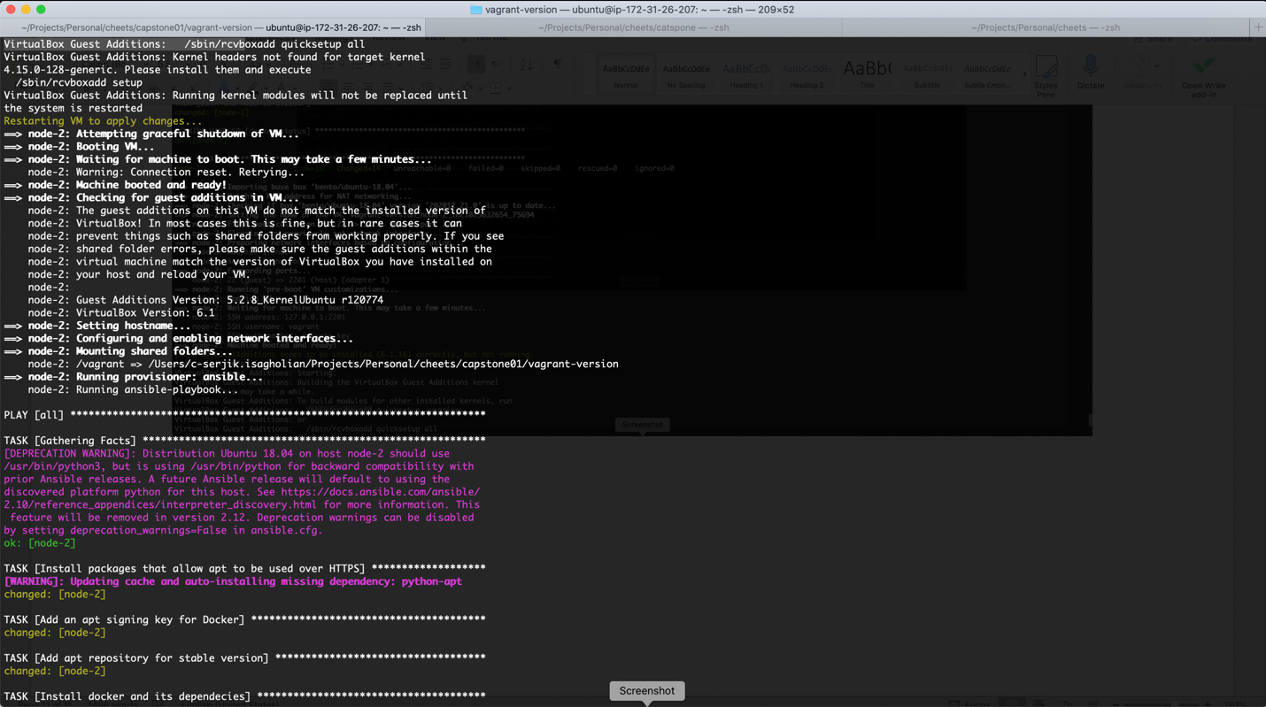

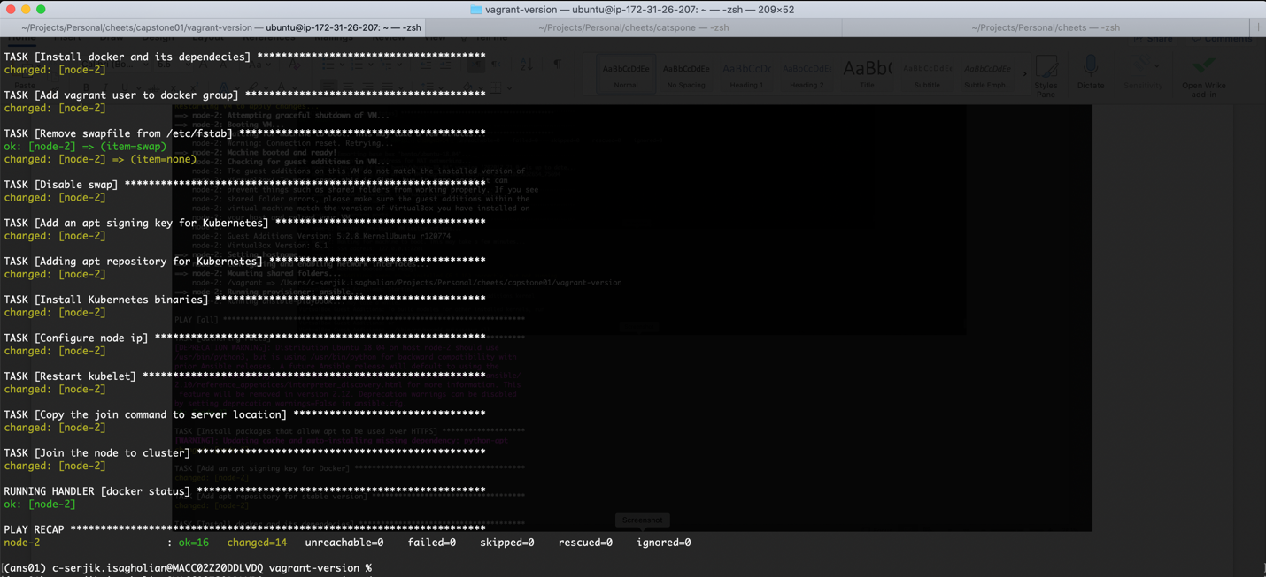

**Take snapshot from ETCD**

>> vagrant ssh k8s-master # ssh to master node

>> kubectl get pods -n kube-system # Check that etcd-k8s-master is there and running

# Grab correct url for our operation

>> kubectl describe pod etcd-k8s-master -n kube-system | grep advertise

>> export advertise_url=192.168.50.10:2379

# Take the snapshot

>> sudo ETCDCTL_API=3 etcdctl --endpoints $advertise_url \

--cacert /etc/kubernetes/pki/etcd/ca.crt --key /etc/kubernetes/pki/etcd/server.key \

--cert /etc/kubernetes/pki/etcd/server.crt get "" --prefix=true -w json > etcd.json

# See what we have got on etcd:

>> for k in $(cat etcd.json | jq '.kvs[].key' | cut -d '"' -f2); do echo $k | base64 --decode; echo; done

>> for k in $(cat etcd.json | jq '.kvs[].value' | cut -d '"' -f2); do echo $k | base64 --decode; echo; done

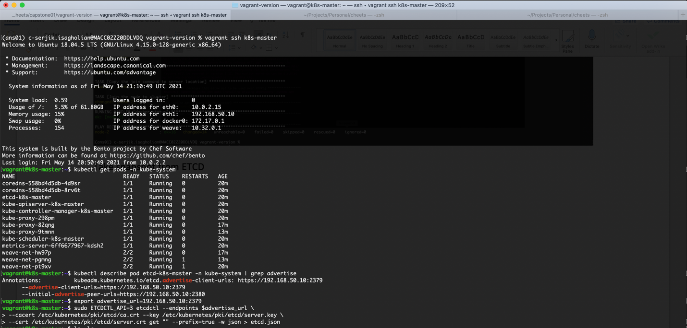



**Check Keys and values inside snapshot**

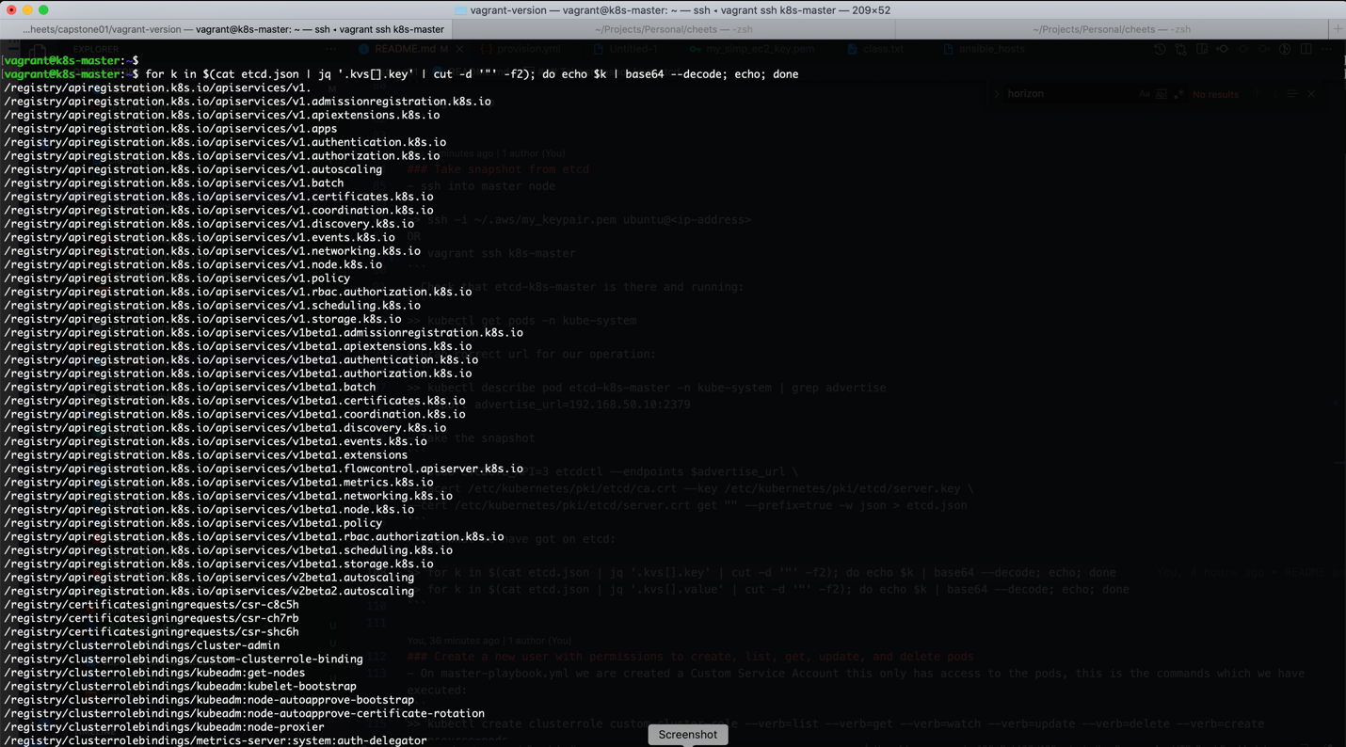

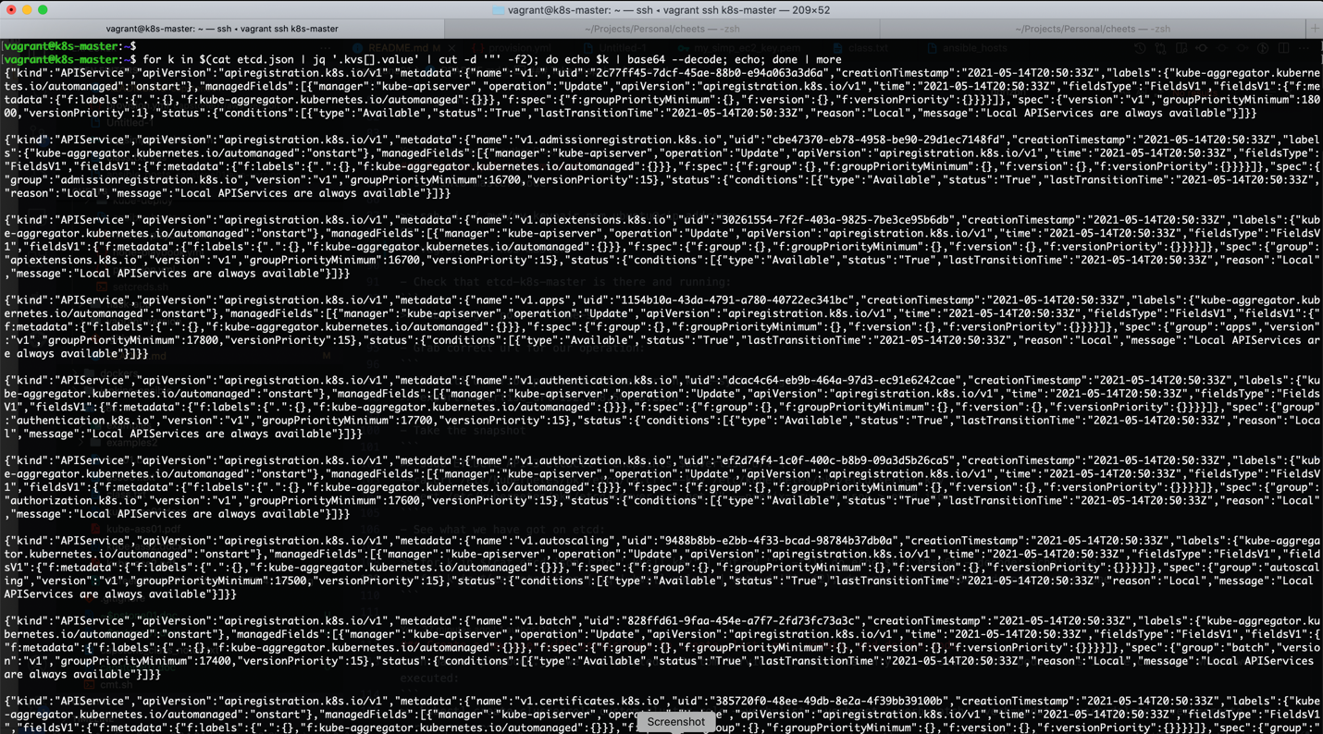

**Check Custom Service Account permissions**

We have created our custom-cluster-role and custom-service-account as part of master-playbook.yml.

- name: Create Custom Roles and Service Account

become: false

shell: |

kubectl create clusterrole custom-cluster-role --verb=list --verb=get --verb=watch --verb=update --verb=delete --verb=create --resource=pods

kubectl create serviceaccount custom-service-account

kubectl create clusterrolebinding custom-clusterrole-binding --clusterrole=custom-cluster-role --serviceaccount=default:custom-service-account

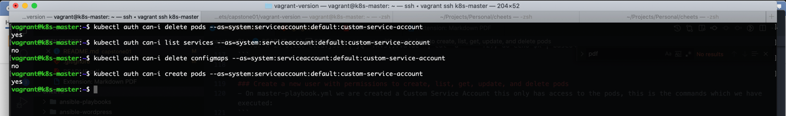

**Load Generate and Auto Scaling**

We have created a 2 deployments for flaskapp and mysql, plus services for each, NetworkPolicy for mysql deployment and HorizontalPodAutoScaler for flaskapp. The all run as part of our master-playbook.yml.

- name: Copy deployment files

become: false

copy:

src: ./kube-deploy

dest: ./

- name: Deploy application

become: false

shell: |

cd $(pwd)/kube-deploy

kubectl apply -k ./

The kube-deploy contains yaml files for Kubernetes.

Kustomization.yaml

secretGenerator:

- name: mysql-pass

literals:

- password=centos

resources:

- mysql-deployment.yaml

- flaskapp-deployment.yaml

mysql-deployment.yaml

apiVersion: apps/v1 *# for k8s versions before 1.9.0 use apps/v1beta2 and before 1.8.0 use extensions/v1beta1*

kind: Deployment

metadata:

name: flask-mysql

labels:

app: fk-mysql

spec:

selector:

matchLabels:

app: fk-mysql

strategy:

type: Recreate

template:

metadata:

labels:

app: fk-mysql

spec:

containers:

- image: mysql:5.6

name: mysql

env:

- name: MYSQL_ROOT_PASSWORD

valueFrom:

secretKeyRef:

name: mysql-pass

key: password

livenessProbe:

tcpSocket:

port: 3306

ports:

- containerPort: 3306

name: mysql

---

apiVersion: v1

kind: Service

metadata:

name: flask-mysql

labels:

app: fk-mysql

spec:

ports:

- port: 3306

selector:

app: fk-mysql

clusterIP: None

---

kind: NetworkPolicy

apiVersion: networking.k8s.io/v1

metadata:

name: flask-mysql

spec:

podSelector:

matchLabels:

app: fk-mysql

ingress:

- from:

- podSelector:

matchLabels:

app: fk-frontend

flaskapp-deployment.yaml

apiVersion: apps/v1 *# for k8s versions before 1.9.0 use apps/v1beta2 and before 1.8.0 use extensions/v1beta1*

kind: Deployment

metadata:

name: flaskapp

labels:

app: fk-frontend

spec:

replicas: 1

selector:

matchLabels:

app: fk-frontend

strategy:

type: Recreate

template:

metadata:

labels:

app: fk-frontend

spec:

containers:

- image: serjik1024/flaskapp:1.0

name: flaskapp

env:

- name: DB_HOST

value: flask-mysql

- name: DB_PASSWORD

valueFrom:

secretKeyRef:

name: mysql-pass

key: password

ports:

- containerPort: 5000

name: flaskapp

resources:

limits:

cpu: 500m

requests:

cpu: 200m

status: {}

---

apiVersion: v1

kind: Service

metadata:

name: flaskapp

labels:

app: fk-frontend

spec:

ports:

- port: 5000

protocol: TCP

targetPort: 5000

selector:

app: fk-frontend

type: NodePort

status:

loadBalancer: {}

---

apiVersion: autoscaling/v1

kind: HorizontalPodAutoscaler

metadata:

creationTimestamp: null

name: flaskapp

spec:

maxReplicas: 3

minReplicas: 1

scaleTargetRef:

apiVersion: apps/v1

kind: Deployment

name: flaskapp

targetCPUUtilizationPercentage: 50

status:

currentReplicas: 0

desiredReplicas: 0

this is the output of our application with load generator:

